

Department of Applied Physics and Astronomy
University of Sharjah
Conservation of Mechanical Energy

Name: ID#:
Objectives:
1- To verify the conservation of mechanical energy by determining the relationship between kinetic energy and potential energy
2- To study the difference between conservative and nonconservative forces

Apparatus:
https://phet.colorado.edu/sims/html/energy-skate-park-basics/1.1.0/energy-skate-park-basics_en.html

Theory:
Energy, in physics, is the ability to do work. It may exist in different forms like potential, kinetic, thermal, electrical, chemical, nuclear, or other various forms. In the International System of Units (SI), energy is measured in joules.
Mechanical energy (E) is the sum of the potential energy (U) and kinetic energy (K) in a system. The principle of the conservation of mechanical energy states that the total mechanical energy in a system remains constant as long as the only forces acting are conservative forces.
A good way to think of conservative forces is to consider the path of the object; if the work done by this force on an object is independent of the path taken by the object, the force is a conservative force, such as the force of gravity, on the other hand, if the work done by the force on an object is depends on the path taken the force is said to be non-conservative force, like the kinetic friction force.
In this experiment, you will make measurements to demonstrate the conservation of mechanical energy and its transformation between kinetic energy and potential energy.
The mechanical energy can, however, be transformed between its kinetic and potential forms, so, any change in the kinetic energy will cause a corresponding change in the potential energy, and vice versa.
If the initial velocity of the object is zero, then the kinetic energy at any given time is:
$\text{K }=\frac{1}{2}{\text{ m v}}^{2}$

Where v is the instantaneous velocity and m is the mass of the object
While the gravitational potential energy of an object at a height y is given by:
$\text{U }=\text{ m}gy$

Where the potential energy is chosen to be zero at height y=0.

If the mechanical energy is conserved (in the absence of friction), therefore we can say that the sum of the K and U anywhere during the motion must be equal to the sum of the K and the U anywhere else in the motion.
${\text{ K}}_{1}+{\text{ U}}_{1}={\text{ K}}_{2}+{\text{ U}}_{2} \text{.}\text{.}\text{.}\text{.}\text{.}\text{.}\text{.}(1)$

$\frac{1}{2}{\text{ m v}}_{1^{2}}+{\text{ m g y}}_{1}=\frac{1}{2}{\text{ m v}}_{2^{2}}+{\text{ m g y}}_{2} \text{.}\text{.}\text{.}\text{.}\text{.}\text{.}\text{.}\text{.}\text{.}\text{.}\text{.}(2)$

Procedure:
This simulation (https://phet.colorado.edu/sims/html/energy-skate-park-basics/1.1.0/energy-skate-park-basics_en.html) shows how kinetic and potential energy are related, in a scenario similar to the roller coaster as shown in Figure 1. Observe the changes in K and U by clicking on the bar graph boxes. Also we will try two differently shaped skate parks. Drag the skater to the track to start the animation. The bar graphs show how K and U are transformed back and forth.

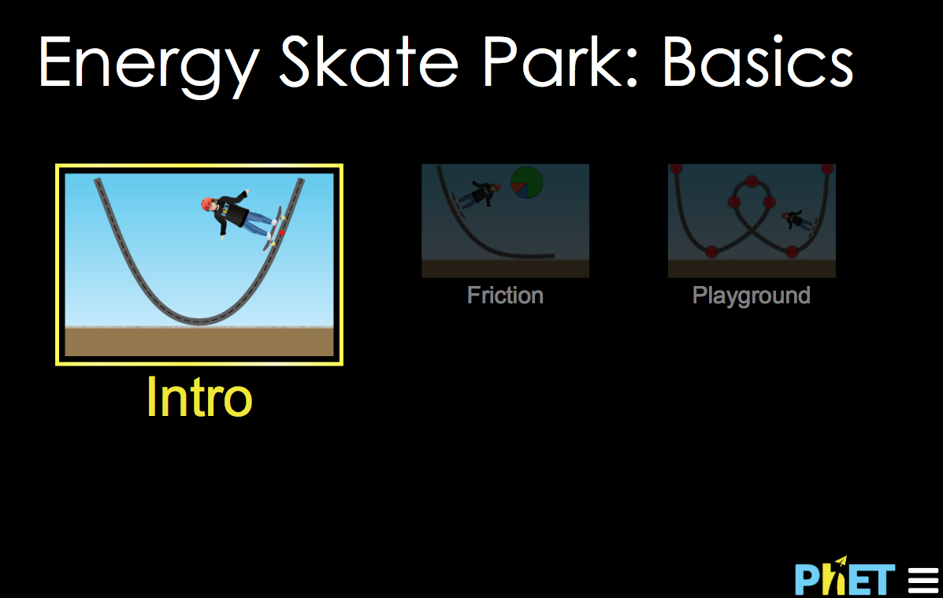
Figure 1

Part (1): Conservative and nonconservative forces
1- Open the following link: https://phet.colorado.edu/sims/html/energy-skate-park-basics/1.1.0/energy-skate-park-basics_en.html
2- Go to Google Chrome and select (Energy Skate Park: Basics) then click on the “Intro” graph box.
3- Click on (Quarter skateboard ramp) ( )
4- Show (Bar Graph), (Grid), (Speed), and select the smallest mass (consider m_{small}=50 kg).
5- Drag the skater to the top of the track and start the animation (Figure 2a).
6- To take an accurate data, click on (Slow Motion) then Pause and play step by step.
7- Record the maximum height at the top of the ramp and the speed of the skater at the bottom of the ramp and then record the results in data table 1a in your lab report.
(Note: the spedometer scaled by 1m/s with a maximum reading of 20 m/s)
8- Drag the skater upward to the same vertical height (6 m) as shown in Figure 2b and release it from rest “free fall” then record the final speed before it hits the ground.
9- Calculate the potential energy and kinetic energy for both cases; ramp and free fall, then compare the results and write down your conclusion.
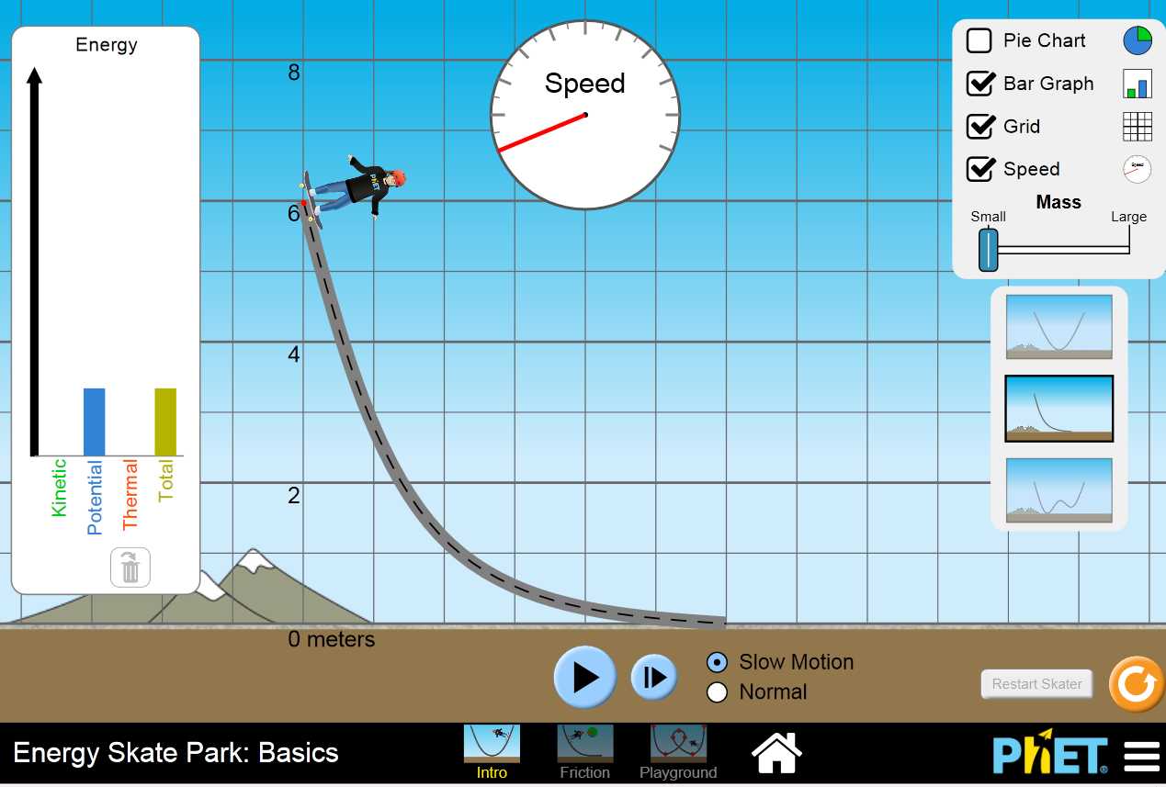
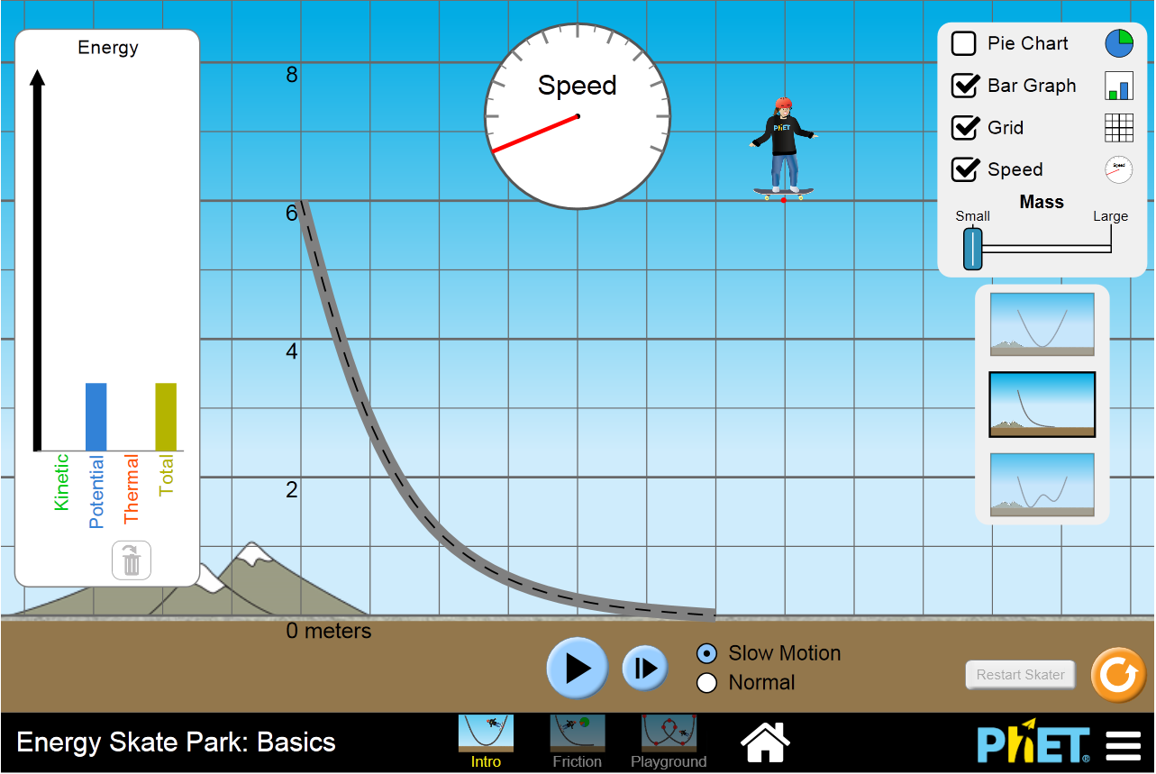
10- Change the mass of the skater to large mass (consider m_{large}=100 kg) and repeat the previous steps then record the results in data table 1b.
(a) (b)
Figure 2

Table 1a
mass of skater m = 50 kg, g = 9.80 m/s²
Type of Motion | Maximum Height  (m) | Potential Energy  (J) | Final speed  (m/s) | Kinetic Energy  (J)
(Skateboard Ramp)
(Free Fall)

Table 1b
mass of skater m = 100 kg, g = 9.80 m/s²
Type of Motion | Maximum Height  (m) | Potential Energy  (J) | Final speed  (m/s) | Kinetic Energy  (J)
(Skateboard Ramp)
(Free Fall)

i- Does the work done by gravity depend on the path taken? Explain

………………………………………………………………………………………………
ii- Is gravitational force conservative or non-conservative? Why?

………………………………………………………………………………………………

iii- Does the speed of the skater depends on its mass?

………………………………………………………………………………………………

Part (2): Conservation of Mechanical Energy
In this part we will build a system similar to the real system in the lab that we use to verify the conservation of mechanical energy principle as illustrated in figure 3.
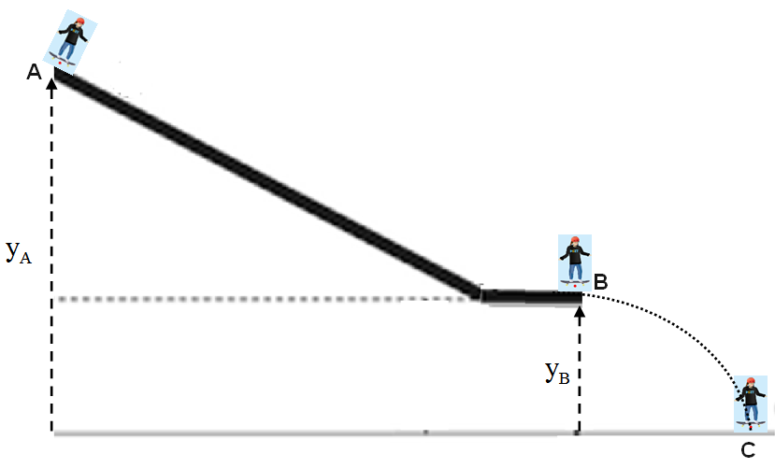

Figure 3

1- Open (https://phet.colorado.edu/sims/html/energy-skate-park-basics/1.1.0/energy-skate-park-basics_en.html)
2- Go to Google Chrome and select (Energy Skate Park: Basics)
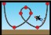
3- Double Click on (Playground) 4- Show (Grid), (Speed), (None friction) and select the smallest mass (m_{small}=50 kg).

5- Use the (Playground) to build the same track as shown in Figure 4.
6- Drag the skater to the top of the track at point A and start the animation (Note: v_{A}=0).
7- Measure the height of the point A from the ground (y_{A}), the height of B (y_{B}), the speed of the skater at B (v_{B}) and its speed at C (v_{C}) then record the results in data table 2 in your lab report.

8- To take an accurate data for the speed, click on (Slow Motion) then Pause and play step by step.
9- Calculate the potential energy, kinetic energy and mechanical energy of the skater at points A, B and C, then compare the results and write down your conclusion.
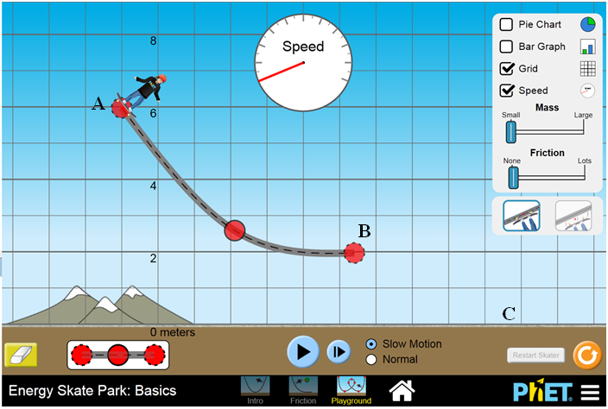

Figure 4

Table 2
mass of skater: m = 50 kg, g = 9.80 m/s²

Point | Height (y)  (m) | Speed (v)  (m/s) | Potential Energy (U_{g})  (J) | Kinetic Energy (K)  (J) | Mechanical Energy (E)  (J)
A
B
C

i- Calculate the ratio of the mechanical energy at B and mechanical energy at A (E_{B}/E_{A}) and (E_{C}/E_{B}). What do these ratios tell you about the conservation of energy?

………………………………………………………………………………………………

………………………………………………………………………………………………

ii- Is the mechanical energy conserved between A and B? Explain

………………………………………………………………………………………………

iii- Is the mechanical energy conserved between B and C? Explain

………………………………………………………………………………………………
Questions:
1- Define the energy and name three of its forms.

………………………………………………………………………………………………

………………………………………………………………………………………………

2- What is the difference between conservative and non-conservative force? Give an example of each force.

………………………………………………………………………………………………

………………………………………………………………………………………………

3- Write down the principle of conservation of mechanical energy.

………………………………………………………………………………………………

………………………………………………………………………………………………

4- A single frictionless roller-coaster car of mass m = 750 kg tops the first hill with speed v= 15 m/s at height h = 40 m as shown
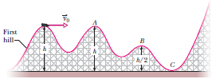
i- Find the speed of the car at B and C

………………………………………………

………………………………………………

………………………………………………

………………………………………………………………………………………………

………………………………………………………………………………………………

ii- If mass m were doubled, would the speed at B increase, decrease, or remain the same?

………………………………………………………………………………………………

5- Conclusions:

………………………………………………………………………………………………

………………………………………………………………………………………………

………………………………………………………………………………………………

………………………………………………………………………………………………

………………………………………………………………………………………………

